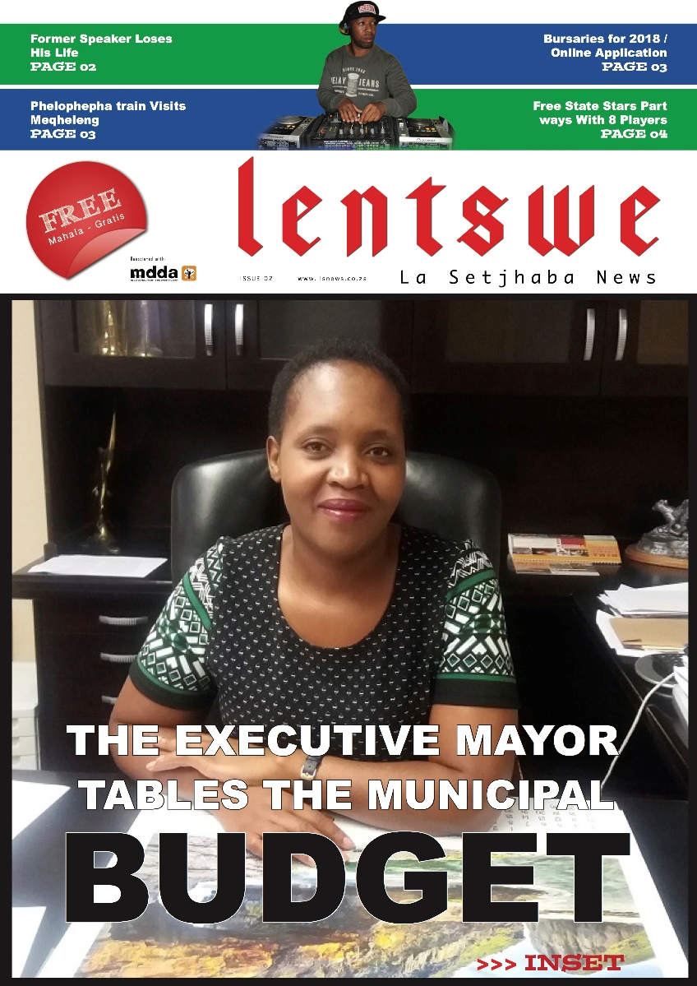
Lentswe La Sechaba
Lentswe La Sechaba is a project of Letlama Foundation, a non-profit organisation that was started by the youth of Meqheleng in 2012 to address issues of poverty and unemployment in the community. Lentswe La Sechaba is an eight page community newspaper that will be produced monhly in both Sesotho (60%) and English (40%) The paper will be produced on a monthly basis. The newspaper is targeted at the entire family with a specific emphasis on the youth.

Contact
Mboweni Letlama
Publisher
073 690 2312
mboweniletlama@gmail.com

