PRESS STATEMENT

FOR IMMEDIATE RELEASE
__________________________________________________________________________________________

ANNOUNCEMENT: APPOINTMENT OF MR THEMBA TC DLAMINI AS MDDA CEO

Johannesburg, South Africa, 11 January 2016. The Board of the Media Development and Diversity Agency (MDDA) is pleased to announce the appointment of Mr Themba TC Dlamini as Chief Executive Officer (“CEO”) of the Agency, as of 1 January 2017.

With his former roles including Managing Director of the Black Management Forum, and Chief Executive Officer of the National Gambling Board, the Independent Communications Authority (ICASA) and the Construction Education and Training Authority (CETA), Mr Dlamini brings to the Agency a wealth of experience at a strategic leadership level in both the public and developmental sector. Other positions he has held include, within the Government of South Africa, Deputy Director-General responsible for Corporate Services and Governance at the Department of Science and Technology and Special Advisor to the Minister of Labour.

Mr Dlamini is a member of the National Planning Commission (NPC). He holds a Bachelor of Arts degree in Economics, and a Master of Arts in Development Economics. He serves on a number of boards including the North West Development Corporation (NWDC); the National Library of South Africa (NLSA) and the National Home Builders Registration Council (NHBRC).

Commented Ms Phelisa Nkomo, Chairperson of the MDDA Board: “Mr Dlamini assumes the leadership of the MDDA at a crucial juncture in the development of the MDDA, and of the community media sector as a whole.

”A rapidly changing technological and media landscape, combined with significant shifts in the socio-economic environment, highlight the increasingly important role of the Agency in ensuring the continued growth and sustainability of community media.

“Mr Dlamini’s proven track record of leadership of entities through such dynamic times will prove invaluable to ensuring that the MDDA continues to fulfil its mandate in promoting and creating an enabling environment to redress exclusion and marginalization of disadvantaged communities and persons from access to the media - as audiences, owners, managers and producers of the media.“

The MDDA is a statutory development agency, deriving its mandate, from Section 16 and 32 of the Constitution Act No. 108 of 1996, thereby providing for freedom of expression and access to information. As a partnership between the South African Government and major print and broadcasting companies, it promotes and assists in the development of community media and small commercial media in South Africa and the transformation of the media, by providing support (financial, capacity building, etc.) in terms of the MDDA Act No 14 of 2002. It also aims to raise public awareness with regard to media development and diversity issues, and to encourage media literacy and a culture of reading. For further information: www.mdda.org.za
__________________________________________________________________________________
Issued by:
MDDA Communications: Cheryl Langbridge 011 643 1100/082 493 6184
cheryl@mdda.org.za
___________________________________________________________________________________
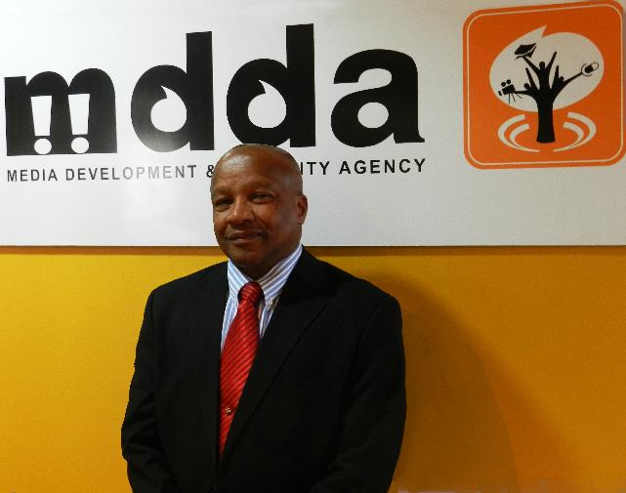
MR THEMBA TC DLAMINI

