The Sports Eye
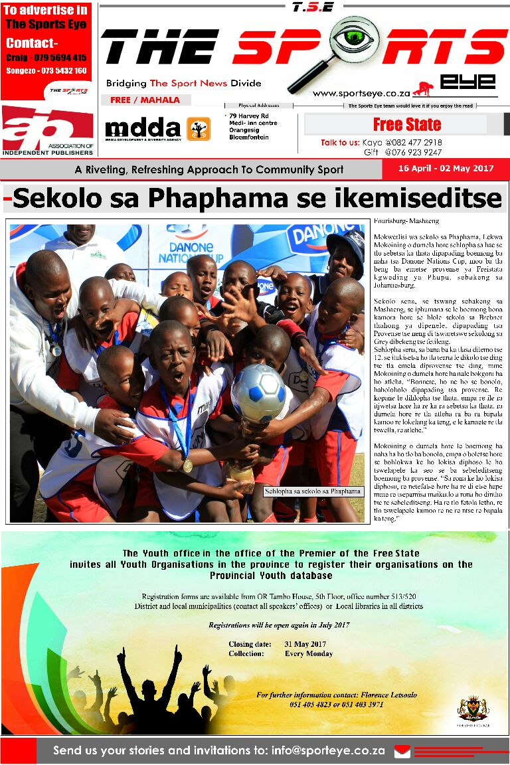
The Sports Eye, published by Izindwe Marketing, a 100% black-owned Close Corporation, is an initiative by youth and focuses mainly on sports development. The newspaper was started in 2009 and is based in the City of Mangaung, targeting mainly the Xhariep District Municipality in the Free State. The 12-page tabloid is published twice a month and is distributed free of charge. The Sports Eye strives to encourage and inspire young people to become interested in participating and supporting sports activities in their areas, as well as nurturing a culture of reading. Currently, the editorial content is in English, but going forward the project has committed to publishing in Afrikaans, isiXhosa and seSotho.

Contact
Khayalethu Mantsantsa,Publisher
0824772918
kaya@sportseye.co.za

